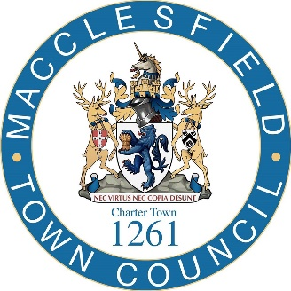

2024 ANNUAL Town MEETING Miuntes
Monday 22nd April 2024
In attendance:
17 people

Councillors:
James Barber, Sarah Bennett-Wake, David Edwardes, Emma Gilman, Alift Harewood, Sandy Livingstone, Mick Warren and Fiona Wilson.

Officers: Town Clerk, Assistant Town Clerk, Communications Officer and Events Officer.

- Welcome from the Mayor of Macclesfield
The Mayor of Macclesfield welcomed everyone to the meeting and explained

- Apologies for absence.
Cllr Mike Hutchison

- Minutes of the Annual Town Meeting 20th March 2023
The minutes were noted.

- Updates for Town Council
The Mayor, Cllr Chris Wilcock, Cllr Fiona Wilson, Town Centre Regeneration Champion and Cllr Sandy Livingstone, Deputy Mayor, along with the Town Clerk, Assistant Town Clerk, Communications Officer
and Events Officer talked through a presentation of the highlights of the past year including:

The Key Achievements for the Council
- The Mayor’s theme ‘’Live Macclesfield, Love Macclesfield
- Parks and Play Areas
- Calendar of community events
- Town centre regeneration and UKSPF funding for renovating the indoor market. Public realm and museum on the street project.
- Toilets for Public Use
Further information was presented on:
- Council Communications
- Community grants given by the Council
- The work of the Rangers in the public realm
- 3 x Gold at Britain in Bloom
- The Plans for a South Park Pavilion

- To consider resolutions and questions of which written notice has been given.
There were no written resolutions.

- To receive reports from electors (Discussion and Open Forum).

A question from the floor was asked about the possibility of a neighbourhood plan for Macclesfield. Fiona Wilson responded by saying that the Local Plan for Cheshire East was currently out for consultation, and this was a more important document where planning and decision making was concerned. She also added that the Town Council had completed a Town Centre Conservation Area Appraisal and a Character Assessment for Macclesfield and both can be found on the town council website.

Sarah Bennett-Wake thanked the Town Hall Officers for their hard work and in turn the Town Clerk thanked all the Councillors for their support and ambition for the town.

Chair Cllr Chris Wilcock
Clerk Laura Smith

Meeting closed 6.41pm

