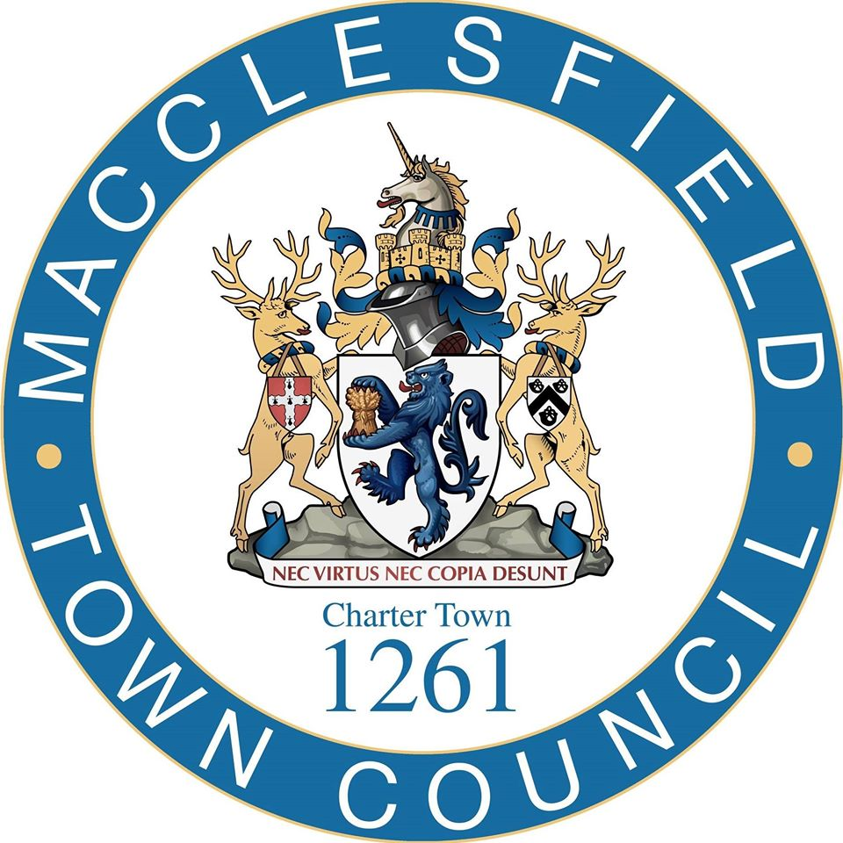

Community Pavilion Construction Project
South Park, Macclesfield

Invitation to Tender - Stage 1

Please ensure that you read this document carefully and fully

This document is the property of Macclesfield Town Council. All rights reserved. This document contains confidential information, which is not to be copied or discussed without express authority from Macclesfield Town Council.
Your completed tender must be returned via the nominated e-tendering system and be received no later than Midnight 16th September 2024

Table of Contents
1. Introduction & Background 3
2. The Procurement Process 6
3. How to Make a Bid 7
4. Tender Queries 8
5. Tender Timescales 9
6. Tender Evaluation & Selection 10
7. Terms & Conditions 16

Appendices

Appendix A Specification & Supporting Information
Appendix A.1 Draft Drawings
Appendix B Selection Questionnaire Template
Appendix C Quality Response Template
Appendix D Cost Response Template
Appendix E Declarations Template
Appendix F IFC Preliminaries and General Conditions of Contract

Introduction & Background

1.1 About Macclesfield Town Council

The principal function of the Town Council is to represent local interests and to promote and watch over particular interests of Macclesfield Town Council (MTC) has an annual budget of over £1m and was created to represent the town’s interests regionally and nationally, informing the development and delivery of local services as well as local planning issues.

The following list are examples of the work of Macclesfield Town Council:

- Community Grants/Development
- Floral Displays/Town Ranger
- Christmas Lights
- Making the Town Attractive
- Street Sports
- Support CCTV Services
- Tourism Promotion & Supporter Visitor Centre
- Community Events
- Eco Summit & Youth Summit
- Mayor of Macclesfield
- Parkrun & Junior parkrun
- Funding Parks and Play Areas
- Remembrance Events
- Statutory Consultee for all Macclesfield Planning Applications
- Allotments

MTC has established a role in improving the facilities in our town and has recently funded the delivery of new public toilets in the indoor market in the town centre.

Further information on MTC can be accessed by visiting www.macclesfield-tc.gov.uk .

1.2 Tender Background

MTC is seeking to appoint a suitably skilled and experienced construction contractor to demolish the existing pavilion in South Park, Macclesfield, and construct a new community pavilion in its place.

This project has been in development for many years and has the backing of many residents of the town.

South Park is the largest park in Macclesfield. It celebrated its centenary in 2022 after it was gifted to the people of Macclesfield by local Alderman William Frost. It has been a vital green space for residents ever since. The Park is a true asset for our town, and one that we have an opportunity to improve for our residents, our community and to attract visitors from near and far. South Park currently plays host to leisure activities including, play facilities, a skate park, open space for dog walking, tennis, bowls, and a very successful parkrun amongst other outdoor exercise activities.

The park has had a pavilion overlooking its band stand for a number of generations, with the current pavilion building replacing the original following a devastating fire in 1970s. This replacement building was most recently used as a base for the now ceased Connexions service.

Currently the building acts as storage and shelter for the park maintenance team and on an ad hoc basis by the friends of the park group S:Park, the South Park Community Tennis Club and parkrun. Local residents have campaigned for a pavilion building in South Park for the past 20 years. Several in-depth consultations have been carried out with the community group SPARK (The Friends of South Park Group) and the Town Council as well as a recent round of face to-face consultations held in August 2022.

MTC is looking for a commercial organisation to demolish the existing pavilion and construct a new community pavilion in the park. Macclesfield Town Council are asset transferring the building from the local authority and will demolish it and build a fully accessible and environmentally friendly building, available and open to all the community. A building that meets the needs, expectations and ambitions of the community, the park services as well as encouraging visitors to the park. Through project forming and evaluation, a building that is flexible and sustainable and that can provide for the community well into the future

In early 2022, Bower Mattin and Young were hired as architects and were tasked with designing different designs to take to the public for consultation In Aug 2022, we held 4 public consultations, in the park and in the town centre. Over 750 detailed written responses were received. Our residents wish us to proceed with the project and identified two of the five designs that were presented to them. We have merged these two to provide a two-storey building with a number of the design features that were most valued.

The proposed scheme is an environmentally sensitive pavilion designed to provide a wide range of flexible spaces suitable for family gatherings, fitness, dance, and regular cultural events. There will be a Changing Places toilet with baby changing for all park users. The ground floor consists of a large café area with chill out spaces housing local art exhibits and magazines. It will lead to a canopied outdoor terrace with seating overlooking the bandstand. There are also two large multi-purpose rooms which can provide a space for people to gather. The first floor overlooks the park and tennis courts. It will provide an event space for exhibitions, music, comedy nights and large family celebrations of up to 100 people.

It is intended that the new building will reuse the existing pavilion slab and foundations. It will be super insulated and incorporate a turf/sedum roof to create a high thermal mass which will also assist water attenuation. Passive solar gain combined with a heat recovery and recirculation ventilation system and air source heat pumps will be at the core of the renewable energy proposals. Local stone and timber will be used in construction which will feature green walls as a part of the target to control the carbon footprint.

The Procurement Process

2.1 Procurement Route

MTC is advertising this tender opportunity via the Contracts Finder platform and are conducting this tender in line with the Open process. Bids are invited from suitably skilled and experienced contractors with a track record of delivering similar works ideally in a similar geography and within a similar setting. MTC is committed to an open, fair, and transparent procurement process which is seeking to appoint a contractor who can work collaboratively with the project team to deliver a high-quality outcome.

The purpose of this First Stage tender is to appoint a competent and committed contractor who will continue into the second stage process with MTC and its Design Team.

During the Second Stage the contractor will work with the Design Team regarding design development and buildability, to progress towards an agreed project cost based on the approved design and specification information. All costs will be developed on an open and transparent basis and work packages will be tendered and monitored in conjunction with the design team. The Contract Sum will be treated as an Agreed Maximum Price, where any cost over-run (unless agreed otherwise) will be the responsibility of the contractor and any savings to the AMP will be split 50/50 between MTC and the Contractor. All costs will be monitored and agreed with MTC's Cost Consultant.

It is intended that the Preliminaries and Profit elements of the Agreed Maximum Price be treated as a management fee and paid in equal monthly payments corresponding to the agreed contract period.

2.2 Written Tender

Providers wishing to make a bid to deliver the works will be required to provide a formal tender which includes a preliminary selection questionnaire, a written response to a number of set quality questions and a commercial offer setting out the tendered costs to deliver the required services.

2.3 Tender Appointment

Following conclusion of the procurement process, MTC intends to appoint the highest scoring bidder to the deliver the contract. Further detail on how to make a bid, the evaluation process and appointment are detailed below.

How to Make a Bid

3.1 Submission Requirements

Providers expressing an interest in this opportunity are required to submit;

- Appendix B - A completed Selection Questionnaire Template
- Appendix C - A completed Quality Response Template
- Appendix D - A completed Cost Response Template
- Appendix E - A completed Declarations Template

The Selection Questionnaire Template requires bidders to provide the requested information on a self-certified basis. Evidence to support responses is not needed at this stage of the procurement process, however the successful bidder may be required to provide documentary evidence to support their responses prior to final appointment. Where minimum requirements are stated, bidders must meet these standards, or agree to ensure these standards are met prior to contract commencement to be eligible for appointment. Bidders are encouraged to review the Selection Questionnaire document to ensure they can meet any minimum standards set out before completing the remaining tender documentation.

The Quality Response Template requires bidders to provide written responses to a range of set questions. Bidders’ attention is drawn to the conditions and requirements set out in the template.

The Cost Response Template requires bidders to provide their commercial offer to provide the services required. Bidders’ attention is drawn to the conditions and requirements set out in the template.

The Declarations Template requires bidders to agree to the statements set out in the template. Bidders must sign and submit the appropriate forms within the template in order for the submission to be considered.

Please note the following Standing Orders from MTC 34.1, 34.2, 34.3 and 34.4:

- Canvassing of members of the Council or of any committee, directly or indirectly, for any appointment as an employee of the Council shall disqualify the candidate for such appointment. The Town Clerk shall make known the purpose of this sub-paragraph of this Standing Order to every candidate.

- A member of the Council or of any committee shall not solicit for any person any appointment under the Council or recommend any person for such appointment or for promotion; but, nevertheless, any such member may give a written testimonial of a candidate’s ability, experience or character for submission to the Council with an application for appointment, providing they are not part of the selection process.

- Standing Order Nos. 34.1 & 34.2 shall apply to tenders as if the person making the tender were a candidate for an appointment.

- If a candidate for any appointment under the Council is to their knowledge related to any member or the holder of any office of the Council, they and the person to whom they are related shall disclose the relationship in writing to the Town Clerk. A candidate who fails so to do shall be disqualified for such appointment, and, if appointed, may be dismissed without notice. The Town Clerk shall report to the Council or to the appropriate committee any such disclosure.

3.2 Submission Format

Bidders must submit their final tender in writing to the following address in advance of the submission deadline;

Town Clerk,
Macclesfield Town Council
Macclesfield Town Hall
Macclesfield
SK10 1EA
Or email laura.smith@macclesfield-tc.gov.uk

Bidders should ensure that their tender envelopes are securely sealed, and bear no markings, logos, or similar that would identify the bidder and clearly marked "Tender South Park Pavilion"
Any tender received late will be returned promptly to the tenderer by the Proper Officer. A late tender which has been received may be opened in the presence of the two Members to ascertain the name and address of the tenderer but no details of the tender shall be disclosed.

3.3 Business Offer

Bidders should note that any formal response to this invitation to tender constitutes a business offer in line with the terms and conditions set out.

Tender Queries

4.1 All Correspondence

Bidders should note that all correspondence pertaining to the procurement process must be directed via email to; Town clerk, laura.smith@macclesfield-tc.gov.uk

Any contact made directly with any other employee of MTC regarding this procurement is a breach of the terms on which this ITT is issued and may result in a rejection of your ITT without it being considered further.

4.2 Process for Tender Queries

Any questions or clarification requests with regard to the tender must emailed to the stated contact in advance of the deadline set out in the provisional tender timetable. Requests logged after the deadline will not be addressed.

Wherever possible, MTC will aim to answer all queries within three working days. Bidders should note that where practicable, all queries and responses will be shared anonymously with all bidders to ensure a fair and transparent process.

Bidders must indicate if they believe a query is commercially sensitive or where disclosure of such query and/or the answer would be likely to prejudice its commercial interests.

4.3 Ambiguity, Error or Omission

Bidders are kindly requested to notify the nominated MTC contract promptly via email of any perceived ambiguity, inconsistency, error, or omission in this ITT or any supporting documentation including any supplementary information issued during the procurement process.

4.4 Post Tender Clarifications

MTC may seek clarifications on bidders’ responses following the submission deadline. Clarifications may be sought to finalise assessment of tenders; however, any clarification request will not present an opportunity for bidders to augment or amend their submission(s). Bidders should note that where appropriate, MTC reserves the right to model third party and / or associated costs with any proposal received to arrive at a cost for comparison.

Tender Timescales

5.1 Submission Deadline

The deadline for responses is Midnight 16th September 2024

5.2 Tender Timetable

The following table is an approximate timeline for the tender process and is provided for information only. Bidders should note that the timetable is subject to change.

Stage | Date
Tender Issue | 7th August 2024
Query Deadline | 26th August 2024
Tender Submission Deadline | 16th September 2024
Tender Assessment | October 2024
Provisional Contract Award | October 2024
Contract Start & Mobilisation | Jan 2025

Tender Evaluation & Selection

6.1 Procurement Assessment Panel

The procurement assessment panel for this tender exercise will consist of MTC team members, councillors, and nominated consultants from the project team.

6.2 Written Tender Evaluation

The evaluation of this tender will be based on the Most Economically Advantageous Tender (MEAT) with the tender weighted as follows:

- Quality Response – will have an overall weighting of 60%
- Cost Response – will have an overall weighting of 40%

6.3 Quality Assessment Overview

All Bidders are required to submit a completed Quality Response Template and to answer questions associated with each lot they have expressed an interest in. The Quality Response document includes a range of set questions. Unless specifically instructed to do otherwise, bidders should write their responses directly into the document provided and NOT in any other format, ensuring that the document is submitted in either MS Word or PDF format. Further instructions for completion are included within the Quality Response document.

6.4 Quality Question Overview

Bidders are required to answer all questions contained within the Quality Response document. Each question carries its own individual weighting as set out in the table below.

Question No. | Description | Weighting (%)
1 | Relevant Experience | 12
2 | Key Staff | 12
3 | Package Procurement | 12
4 | Environmental Sustainability | 8
5 | Social Value | 8
6 | Draft Programme | 8
Total |  | 60%

Each question will be scored and awarded a weighted score in line with the Quality Assessment Criteria. The total weighted score will be added to the Cost Assessment to arrive at a total tender score.

6.5 Quality Assessment Criteria

Bidders’ responses to quality questions will be assessed by the procurement panel and awarded a score between 0 and 5 in line with the criteria set out in the table below.

Score | Term | Typical Characteristic
0 | Unacceptable | No response or extremely limited response. Response inconsistent and/or unworkable and/or does not address our requirements. Shows extremely limited understanding of, and/or extremely inappropriate approach to, the matter in question.
1 | Poor | Response is limited and is lacking in relation to a significant proportion of material elements, is unworkable and/or inconsistent and only partially meets our requirements. Shows limited understanding of, and/or inappropriate approach to, the matter in question.
2 | Satisfactory | Response broadly responds to our requirements at a reasonable standard. Shows reasonable understanding of, and/or acceptable approach to, the matter in question.
3 | Good | Response meets our requirements at a high standard and exceeds them in one or two respects. Shows very sound understanding of, and appropriate approach to, the matter in question.
4 | Very Good | Response meets our requirements at a very high standard and exceeds them in a number of respects. Shows extremely sound understanding of, and highly appropriate approach to, the matter in question.
5 | Excellent | Exemplary response; exceeds expectations in all respects, and Bidder could not be expected to answer question more comprehensively or appropriately.

Responses to questions within the Quality Response document must not exceed the word count advised and must not refer to any supplementary materials unless expressly requested. Attachments and appendices are only permitted where expressly requested. Photographs and diagrams may be included where necessary, however these should not be used to artificially increase the number of words submitted in a response.

6.6 Minimum Quality Score

MTC Reserves the right, entirely at its own discretion, to disqualify any bidder which fails to reach a minimum quality score of 30%.

6.7 Cost Assessment Overview

All Bidders are required to submit a completed Cost Response Template (Appendix D), and to ensure they have fully completed all of the relevant cells.

Bidders are required to submit itemised costs to include;

- Assessed preliminaries
- Overheads and profit requirement
- Proposed pre-construction fee
- Labour rates
- Daywork rates

Bidders should note that the appointed contractor will be required to lead on any subcontractor package procurement, ensuring that relevant packages are tendered and the MTC construction team involved in assessment.

Rates and costs offered as part of this tender process will be modelled to arrive at a total cost for comparison. The lowest priced tender will received the full weighted score, with higher priced tenders receiving a lower score on a proportional sliding scale.

Where MTC feels costs submitted are not complete, or where an offer will incur third party cost, MTC may estimate these costs and add them to the costs submitted to arrive at the total cost for comparison.

6.8 Unsustainably Low Tenders

In addition to the conditions set out in this ITT, MTC reserves the right, entirely at its own discretion, to disqualify any bid that is considered to be unsustainably low.

Terms & Conditions

7.1 Disclaimers

Any information provided in connection with the procurement of the proposed services in this ITT or the documents accompanying is provided for information only. Whilst the documentation has been prepared in good faith, it does not purport to be comprehensive or to have been independently verified.

This ITT is issued on the basis that:

- neither MTC nor any of its advisers accept any liability, responsibility, or duty of care to any Organisation (other than MTC) for its adequacy, accuracy, completeness or for anything said or done in relation to the procurement to which this ITT and accompanying documentation relates;
- neither MTC nor any of its professional advisers make any (express or implied) representation or warranty either about the information contained in this ITT and accompanying documentation on which it is based, or about any written or oral information that may be made available to any Organisation, funder, other interested person, or any of their professional advisers;
- nothing contained in this ITT and accompanying documentation constitutes an inducement or incentive in any way to persuade any Organisation to pursue its interest, submit a tender or enter into any framework agreement, contract, or any other related agreement;
- this ITT and accompanying documentation are not intended to provide a basis for any investment decision by any Organisation and should not be considered as a recommendation by MTC or any of their advisers;
- neither this ITT and accompanying documentation nor any information supplied by MTC should be relied on as a promise or representation as to the future;
- this ITT and accompanying documentation do not constitute or involve any offer capable of acceptance, it is not intended to create a binding contract and it is not capable of creating such a contract by any subsequent actions; and
- no implied contract is to arise between MTC and any Organisation resulting from any Organisation’s compliance with this ITT and accompanying documentation by submitting any tender or from any matters related to it.
All warranties, conditions and other terms implied by statute or common law are excluded to the fullest extent permitted by law.

7.2 Confidentiality

All information contained in this document is considered to be of a confidential nature. You are reminded of your obligation not to disclose information contained herein to any third party without prior agreement. MTC in turn assures confidentiality to all respondents of this Invitation to Tender (ITT).

7.3 Right of Rejection & Appointment

MTC reserves the right to accept or reject any or all responses to the ITT. MTC reserves the right not to appoint a provider following this procurement process.

7.4 Costs

MTC shall not be liable for any costs incurred by you in the preparation of your proposal or any other associated costs related to participating in this procurement process. MTC reserves the right not to accept any offer submitted as part of the ITT.

7.5 Right of Incorporation

The Bidder’s response to the ITT constitutes a business offer. MTC may incorporate all or part of the response in any contract or agreement.

