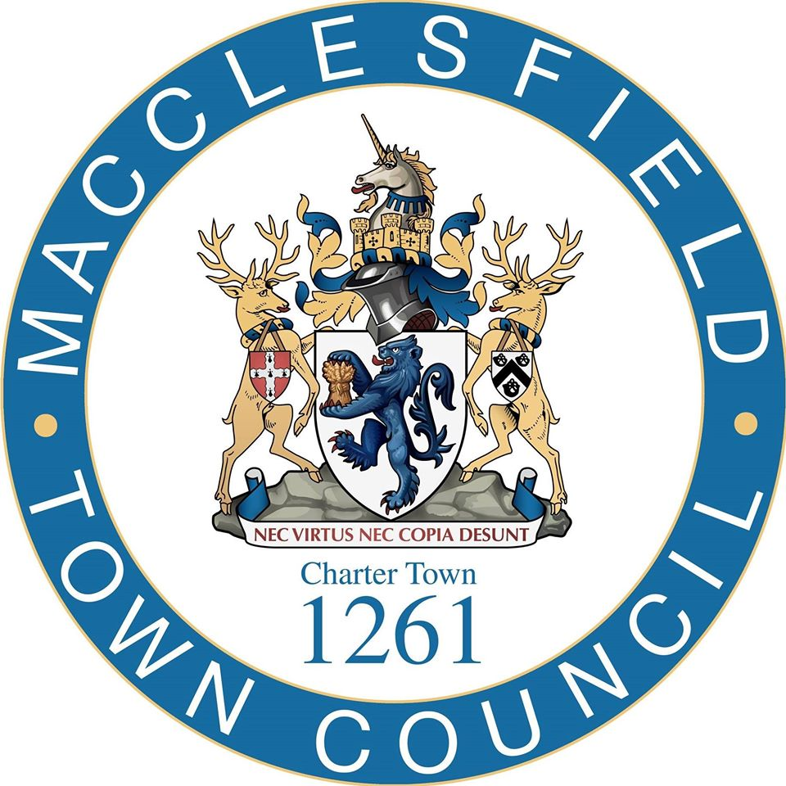

Community Pavilion Construction Project
South Park, Macclesfield

Appendix E

Declarations

FORM OF TENDER

To: Macclesfield Town Council
FAO: The Town Clerk of Macclesfield

Dear Laura Smith

I/We the undersigned, hereby submit our First Stage Tender and offer to perform the Contract, details of which was set out in the ITT supplied to me/us for the purpose of Tendering for the Contract and agree to do so in accordance with the terms of the ITT.

I/We confirm that I/We will enter into the Second Stage process using the cost information provided in my/our Tender. I/We confirm that the price provided in my/our Tender will not be subject to any increase otherwise than as determined in accordance with the Contract.

I/We confirm that this Tender will remain valid and open for acceptance without variation for at least 90 days from the Closing Date for the receipt of Tenders.

I/We confirm that we agree the Contract and undertake that in the event of our Tender being accepted to execute the Contract (subject to any minor amendments which have been accepted by the Council) within four (4) weeks from the date on which I/we receive notification that our Tender is successful and in the interim provide the Services in accordance with the Contract (subject to such amendments).

I/We confirm that attached to this Tender are the following:

- Completed Anti-Collusion Certificate

- Completed Anti-Canvassing Certificate

I/We confirm that the information supplied to you and forming part of this Tender, including, for the avoidance of doubt, any information supplied to you as part of my/our initial expression of interest in Tendering, was true when made and remains true and accurate in all respects.

I/We understand that any false representations, including but not limited to, changes to forms, could result in this Tender being rejected or subsequent contract termination.

I/We confirm and undertake that if any information supplied becomes untrue or misleading that I/We will notify you immediately and will update such information as is required.

I/We confirm acceptance of the terms and conditions provided in appendix 1 without amendment and agree to be bound by such Contract should the Council elect to accept my/our Tender.

Signed
For & on
Behalf of
Date

ANTI-COLLUSION CERTIFICATE

To: Macclesfield Town Council
FAO: The Town Clerk of Macclesfield

Dear Laura Smith

The essence of the public procurement process for selective Tendering for the Contract is that the Council shall receive bona fide competitive Tenders from all Tenderers.

In recognition of this principle I/we hereby certify that this is a bona fide offer, intended to be competitive, and that I/we have not fixed or adjusted the amount of the offer or the price in accordance with any agreement or arrangement with any other person (except any sub-contractor identified in this offer).

I/We also certify that I/We have not done, and undertake that I/We will not do, at any time during the Tender process or in the event of my/our Tender being successful while the resulting Contract is in force, any of the following acts:

- enter into any agreement or agreements with any other person that they shall refrain from Tendering to the Council or as to the amount of any offer submitted by them; or

- inform any person, other than the Council , of the details of the Tender or the amount or the approximate amount of my/our offer except where the disclosure was in confidence and was essential to obtain insurance premium quotations required for the preparation of the Tender; or

- cause or induce any person to enter into such an agreement as is mentioned in paragraph 1) and 2) above or to inform us of the amount or the approximate amount of any rival Tender for the Contract; or

- commit any offence under the Public Bodies Corrupt Practices Act 1889, Bribery Act 2010 nor under Section 117 of the Local Government Act 1972; or

- offer or agree to pay or give or actually pay or give any sum of money, inducement or valuable consideration directly or indirectly to any person for doing or having done or causing or having caused to be done in relation to any other Tender or proposed Tender for the performance of the Project covered by the Tender any act or omission.

In this Certificate the word “person” includes any person, body or association, corporate or incorporate and “agreement” includes any arrangement whether formal or informal and whether legally binding or not.

I/We agree that the Council may, in its consideration of the offer, and in any subsequent actions, rely upon the statements made in this certificate.

Signed
For & on
Behalf of
Date

ANTI-CANVASSING CERTIFICATE

To: Macclesfield Town Council
FAO: The Town Clerk of Macclesfield

Date: …………………………….

Dear Laura Smith

I/we hereby certify that I/we have not canvassed any Director, employee, contractor or adviser of the Council in connection with this Tender and the proposed award of the Contract by the Council, and that no person employed by me/us or acting on my/our behalf, or advising me/us, has done any such act.

I/we further hereby undertake that I/we will not canvass any Director, employee, contractor or adviser of the Council in connection with this Tender and the proposed award of the Contract and that no person employed by me/us or acting on my/our behalf, or advising me/us, will do any such act.

I/we agree that the Council may, in consideration of this bid, and in any subsequent actions, rely upon the statements made in this Certificate.

Signed
For & on
Behalf of
Date

