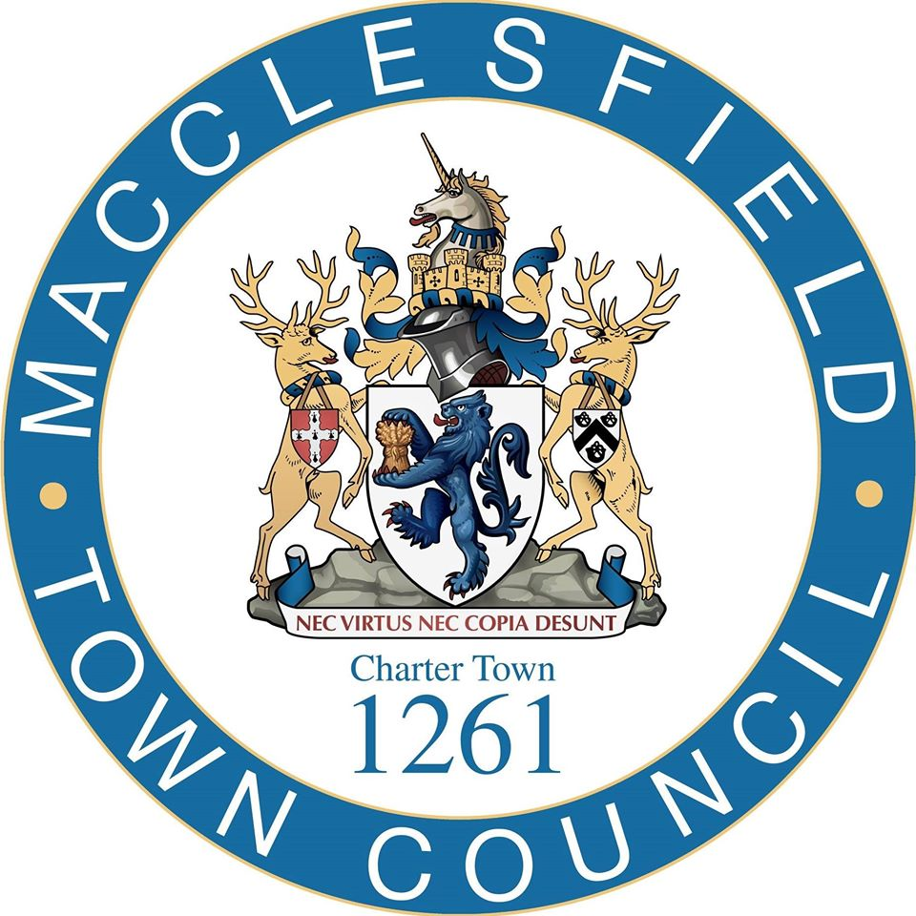

Community Pavilion Construction Project
South Park, Macclesfield

Appendix C

Quality Response Template

Instructions for Bidders

- Bidders must respond to the quality questions set by entering their responses directly into this form. Only where specifically requested should bidders provide additional information and / or attachments.
- Marks are awarded for clear and concise responses which are relevant to the requirement, tailored to this procurement, with examples and explanations given when applicable. Where possible responses should be structured and concise, and where appropriate clearly set out the bidder’s offer
- All information requested should be provided in the order and format set out in this tender. Unsolicited attachments, documentation and / or cross referencing of responses will not be evaluated unless they are expressly requested.
- Where a specific question in the template asks for additional information, this should be uploaded with the tender submission. Such material should be clearly marked and subtitled with your organisation’s name and the question to which it relates. General sales literature or promotional brochures etc. will not be considered.
- The word limits referred to are the maximum number of words applicable to each response. Word limits exclude titles, headings, charts, tables, and diagrams although these should not be excessively used to increase word count. Responses that exceed the word limit will only be considered up to the word limit.
- Please note that we may request clarification of the responses provided or ask for additional information to conclude assessment.
- All questions will be scored on a scale of 0 – 5 and will be weighted in line with the instructions provided within the ITT.
- Bidders should ensure they have read and understood the entire tender pack, including appendices, before completing this document. Your response should be tailored to the requirement, with any firm offers, or initiatives likely to be appended to / adopted in any final contract.

Expression of Interest

Name of bidding organisation:

Q1 – Relevant Experience

Macclesfield Town Council is seeking to appoint contractors with experience of delivering works similar to our requirement, ideally within similar settings. Please provide details of three contracts that are relevant to our requirements. Responses should give a brief description of the services provided, evidence of delivery in line with MTC’s requirements, and detail any added value delivered to the customer organisation.

Contracts should have been delivered during the past three years and you may not reference MTC in this question. Please note that we may take up references from the contacts listed to verify the content of this qualitative response, and you should be prepared to forward any necessary details to assist with this.

(i) Customer organisation
Scope of contract

Start & completion dates

Approx. contract value (£)

Brief description of contract (max 200 words) including evidence of delivery in line with MTC’s requirements
(ii) Customer organisation
Scope of contract

Start & completion dates

Approx. contract value (£)

Brief description of contract (max 200 words) including evidence of delivery in line with MTC s requirements
(iii) Customer organisation
Scope of contract

Start & completion dates

Approx. contract value (£)

Brief description of contract (max 200 words) including evidence of delivery in line with MTC's King’s requirements

Q2 – Key Staff

Please give an overview of the key staff within your organisation, and the key staff that would be deployed to manage this contract if you are successful. You may include abridged CVs as separate attachments to support your response.

Bidder Response – Max 500 words (not including any attachments)

Q3 – Package Procurement

MTC is seeking to appoint a partner that can add value throughout the project and support the delivery of a high quality, value for money project. Please set which elements of the project you will self-deliver, and which you would propose to subcontract. Additionally, please outline your proposals for procuring packages and how you will ensure MTC officers and its design team are fully involved, and that value for money is delivered.

Bidder Response – Max 600 words

Q4 – Environmental Sustainability

Please set out how you will ensure environmental sustainability in the delivery of this project. Your response should give details on your own practices, and how you will incorporate environmental sustainability in the design phase(s).

Bidder Response – Max 500 words

Q5 – Social Value

Please give an overview of the social value commitments you will make to MTC if appointed to deliver this contract.

Bidder Response – Max 500 words

Q6 – Draft Programme

Please provide as a separate attachment, your draft programme setting out key activities and milestones for the delivery of the project.

